**New Compatriot Orientation Workbook**

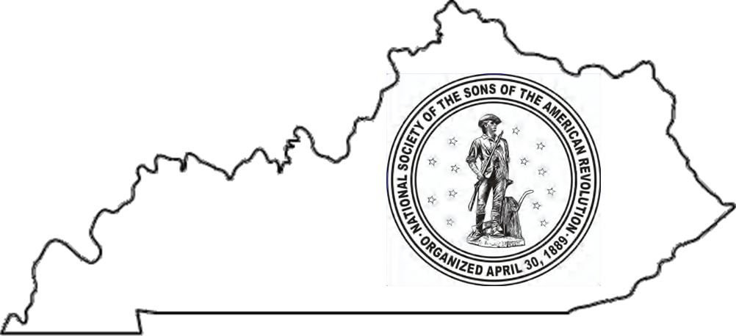

**Kentucky Society**

**of the**

**Sons of the American Revolution**

Revised: March 25, 2025

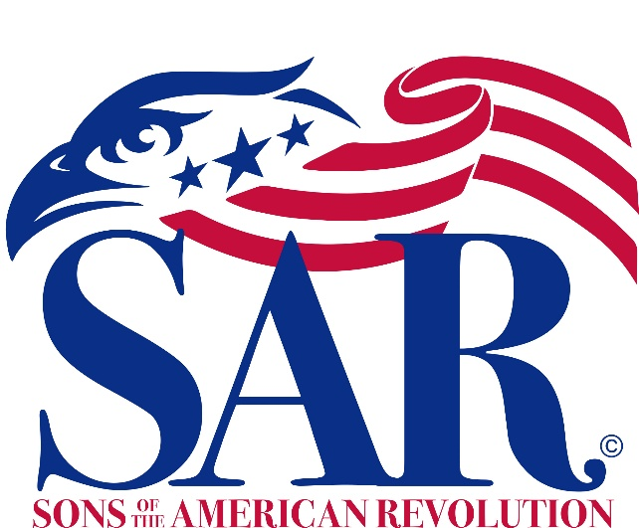

Logo of the National SAR

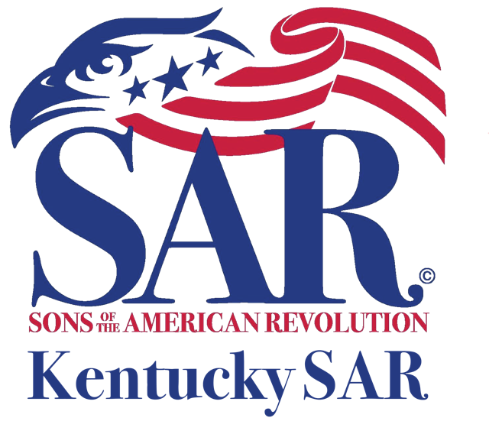

*Logo of the Kentucky SAR*

Compatriot

**Insert New Member Name**

Welcome to the

**Insert Chapter Name**

Table of Contents

WELCOME AND OVERVIEW…………………………………………………………………………………………………………………………5

Acknowledgements………………….……………………………………………………………………………………………………5

Introduction……………………….…………………………………………………………………………………………………………5

Participation…………………….……………………………………………………………………………………………………………5

Mentor………………………….………………………………………………………………………………………………………………5

References………………….…………………………………………………………………………………………………………………5

Terminology……………….………………………………………………………………………………………………………………….6

NSSAR – WHO WE ARE………………………………………………………………………………………………………………………………7

History…………………………………………………….…………………………………………………………………………………….7

Objectives………………………………………………..…………………………………………………………………………………….7

Handbook………………………………………………….…………………………………………………………………………………..7

Headquarters & Library…………………………….……………………………………………………………………………………8

Non-Profit………………………………………………….…………………………………………………….…………………………….8

Apolitical…………………………………………………….………………………………………………………………………………….8

Organization……………………………………………….……………………………………………………….…………………………8

Societies…………………………………………………….………………………………………………………….……………………….9

Seal, Insignia, & Standard…………………………….……………………………………………………….………………………..9

Medals………………………………………………………….………………………….…………………………………………………..10

SAR Pledge/Mission Statement/Recessional….……….……………………………………………………………………..10

Dues……………………………………………………………………………………………………………………………………………..10

Fund Raising………………………………………………………………………………………………………………………………….10

Communication ………………………………………………………………….……………………………………………..………….11

THE CENTRAL DISTRICT………………………………………………………………………………………………………………………………11

Meetings & Events………………………………………………………………………………………………..………………………11

THE KENTUCKY STATE SOCIETY…………………………………………………………………………………………………………………..12

History…………………………………………………………………………………………………………………………………………. 12

Non-Profit/Charitable…………………………………………………………………………………………………………………… 12

Officers………………………………………………………………………………………………………………………………………… 13

Board Of Governors……………………………………………………………………………………………………………………… 13

Executive Committee…………………………………………………………………………………………………………………… 13

Standing Committees…………………………………………………………………………………………………………………… 13

Meetings………………………………………………………………………………………………………………………………………. 13

Dues…………………………………………………………………………………………………………………………………………….. 13

Programs……………………………………………………………………………………………………………………………………… 14

Color Guard………………………………………………………………………………………………………………………………….. 14

DAR………………………………………………………………………………………………………………………………………………. 14

Ladies Auxiliary…………………………………………………………………………………………………………………………….. 14

C.A.R. …………………………………………………………………………………………………………………………………………… 14

Endowment…………………………………………………………………………………………………………………………………. 14

Publications………………………………………………………………………………………………………………………………….. 14

CHAPTER NAME CHAPTER………………………………………………………………………………………………………………………… 15

History…………………………………………………………………………………………………………………………………………. 15

Constitution & Bylaws…………………………………………………………………………………………………………………. 15

Not for Profit Organization and Charitable Organization………………………………………………………………. 15

Officers………………………………………………………………………………………………………………………………………… 15

Meetings……………………………………………………………………………………………………………………………………… 15

Dues and Donations…………………………………………………………………………………………………………………….. 15

Chapter Committees……………………………………………………………………………………………………………………. 15

Opportunities to Participate in the Chapter…………………………………………………………………………………. 15

Americanism Award……………………………………………………………………………………………………………………… 16

Youth Awards………………………………………………………………………………………………………………………………. 16

Flag Award…………………………………………………………………………………………………………………………………… 16

Color Guard………………………………………………………………………………………………………………………………….. 17

Grave Markings …………………………………………………………………………………………………………………………….17

Veteran Service and Support………………………………………………………………………………………………………… 17

Speaker Bureau……………………………………………………………………………………………………………………………. 18

Patriot Research System Support…………………………………………………………………………………………………. 18

250th Anniversary of the American Revolution……………………………………………………………………………. 18

Wreaths Across America……………………………………………………………………………………………………………… 18

Attendance at State and National Meetings………………………………………………………………………………… 19

Appendix A – National SAR Officers & Offices…………………………………………………………………………………………… 20

Appendix B – Kentucky SAR Officers…………………………………………………………………………………………………………. 21

Appendix C – Medals and Certificates………………………………………………………………………………………………………. 22

Appendix D – Chapter Name Chapter Officers………………………………………………………………………………………….. 23

Appendix E – Chapter Name Meetings and Events……………………………………………………………………………………. 24

My Part Participation - Summary Sheet………………………………………………………………………………………… 25

Where I am Willing to Help - Summary Sheet………………………………………………………………………………. 26

# Welcome and Overview

Acknowledgements: The Kentucky Society of the Sons of the American Revolution is grateful for the materials and assistance that the National Society and the Arizona and Ohio Societies have contributed to this Workbook. The Kentucky Society approves of the use of this workbook and modification of its contents as needed to implement member orientation.

Introduction: This Orientation Workbook acquaints you with the National Society of the Sons of the American Revolution (NSSAR), the Kentucky Society of the Sons of the American Revolution (KYSSAR), and your local Chapter.

Each organization allows you to be actively involved in the patriotic, historical, and educational programs that meet the goals and objectives of the entire organization. By joining the NSSAR, you are a dues-paying member of each organization.

The objectives, policies, organizational structures, protocols, and programs are established by the National Society and passed down to the State Society and then to the Chapters. This workbook presents an orientation on the essential aspects of the Society. It also describes your opportunities to be a more patriotic citizen, respect and preserve early American history, and educate others on the founding and preservation of this great republic.

A new member’s early education in the NSSAR is to understand the operation of the chapter and its approach to carrying out the objectives of the Society. It is the new member's understanding and participation at the chapter level that will lead to interest and involvement at the state and national society levels. Involvement at the chapter, state, and national levels is open to all members at any time.

Participation: Right up front, we are asking you to be involved. Recognition of our family history and Revolutionary War ancestors is probably why the majority of us became members of the NSSAR. We ask for your active participation and support of the Society’s objectives of patriotism, education, and history. There are many ways for you to stand out from the crowd as a proud and supportive member. These vary from wearing the member badge or member rosette pin to being involved in the chapter, state, and national activities. You can start now, today, by volunteering to support one of your chapter’s activities or committees, by becoming familiar with the National and State Societies, and by attending State Society and National Society meetings and participating in their committees and programs.

Mentor: The [Insert Chapter Name] has assigned a mentor to you as a new member, and your mentor should be your first contact on questions. Also, your fellow compatriots and chapter officers stand ready to help answer your questions. Information is also readily available from the national, state, and chapter websites as well as the national magazine, state newsletter, and chapter newsletter.

Your mentor’s name is: [Insert Mentor Name]

You can reach him at [Insert Mentor Phone Number] and/or [Insert Mentor Email Address]

References: All the details of the three organizations (national, state, and chapter organizations), are available on the websites of each. You are encouraged to visit these websites and become familiar with each website’s content.

The websites are:

* National Society: **www.sar.org** (follow instructions to establish access)
* Kentucky Society: **www.KYSSAR.org**
* [Insert Chapter Name] : [Insert Chapter Website Address]

Of particular importance in the websites are the Handbook (National Society), Handbook (Kentucky Society), and Constitution and Bylaws (Chapter) that define in detail the objectives, policies, organizational structure, protocols, and programs.

You will also find on the websites: schedules of events and meetings, histories of the organizations, recent developments, important announcements, lists of officers and members, lists of revolutionary war patriots and definitions of youth contests/programs, and submittal deadline dates. The national website also has an online store where you can purchase pins, badges, certificates, stationery, medals, clothing, books, and pamphlets. The National website can also be used to make donations to the national programs.

## Terminology:

**Annual Congress -** sometimes referred to as “Congress”, is the annual convention of the National Society hosted by a State Society. State Societies select delegates to attend based on their membership size, but every compatriot is welcome to attend; spouses and family members are also welcome.

**Board of Trustees** **-** manages the business affairs of the National Society and is the custodian of all National Society property. Each State Society is represented by one Trustee.

**C.A.R.** (pronounced as letters, C-A-R, never as a one-syllable term) **-** is the acronym for the National Society of the Children of the American Revolution.

**Compatriot -** the official designation of a member of the National Society of the Sons of the American Revolution.

**Chapter -** the local organization chartered by a State Society to promote growth in membership and interest in the objects of the National Society.

**DAR** (pronounced as letters, D-A-R, never as a one-syllable term) **-** is the acronym for the National Society of the Daughters of the American Revolution.

**District** **-** is a group of State Societies served by a Vice President General to strengthen the constituent State Societies. The Kentucky Society and all of its chapters are in the Central District.

**General Officer -** the term given to the National Society officers elected at the Annual Congress to a one-year term. The **President General** is the Chief Executive Officer of the National Society. Serving with him, in descending rank, are the Secretary General, Treasurer General, Chancellor General, Genealogist General, Registrar General, Historian General, Librarian General, Surgeon General, and Chaplain General. A Vice President General is nominated by each District (see below) and elected and installed at Congress.

**Ladies’ Auxiliary -** aids the SAR at Chapter, State, and National levels. Membership is open to ladies who are related by marriage or bloodline to NSSAR Members in good standing.

**Leadership Meeting** **-** a meeting held each fall and spring in Louisville, KY, at which national committees meet to make recommendations, and the Board of Trustees manages the business affairs of the National Society.

**Membership categories -** **Regular Member** (members 18 years of age and older), **Junior Member** (members under the age of 18 years), and **Memorial Member** (an approved deceased close relative of an SAR member of the same lineage).

**NSSAR** (pronounced as letters, N-S-S-A-R (or S-A-R for short), never as a one-syllable term) **-** is the acronym for the National Society of the Sons of the American Revolution.

**NSSAR Color Guard** **-** compatriots who attend NSSAR meetings and events properly attired as either Continental Soldiers, militiamen, or Revolutionary-era clergymen.

**NSSAR Education Center and Museum** **-** collocated at 809 West Main Street, Louisville, Kentucky.

**NSSAR Member Badge** **-** worn by a compatriot at NSSAR functions and when representing the NSSAR. It is a Maltese cross of four arms and eight points with a bust of George Washington at its center.

**NSSAR Rosette -** The rosette is a small tightly folded circle of ribbon of the Society’s colors. It is worn by a compatriot, at his discretion, on the left lapel of his jacket, but is not worn simultaneously with the NSSAR Member Badge.

**State Society** **-** chartered by the National Society in any State or Territory, including any foreign country, in which a Society does not exist. State Society shall be subject to the provisions of this Constitution and Bylaws. You are a member of the Kentucky Society of the Sons of the American Revolution (KYSSAR).

**Trustee -** One (1) member from each of the State Societies who is selected by his State Society and then elected by the delegates and delegates at-large at the Annual Congress for a term of one year.

# NSSAR – Who We Are

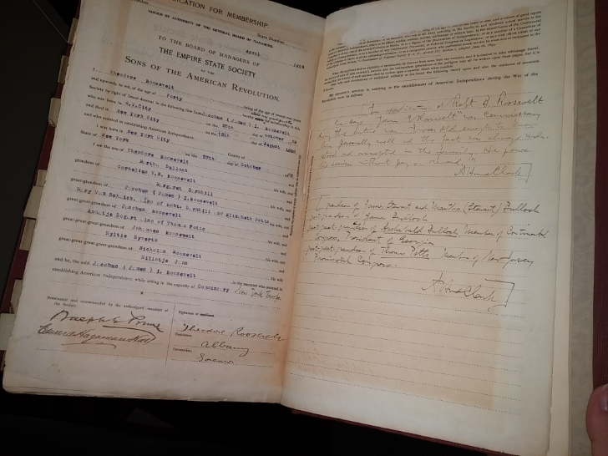History: The NSSAR grew out of a few patriotic organizations that formed during and shortly following the centennial celebration of the United States in the 1870s and 1880s. Originally organized on April 30, 1889, in Washington D.C., the founding members chose this date because it was the 100th anniversary of the inauguration of George Washington as the first President. Chartered by an Act of the U.S. Congress on June 9, 1906, and signed into existence by President Theodore Roosevelt, a NSSAR member, this charter authorizes the granting of charters to state societies and through them to local chapters. Another important date is April 30, 1890, when the first National Congress took place in Louisville, Kentucky. Volume VII of the NSSAR Handbook provides a more detailed history of the NSSAR.

Theodore Roosevelt’s SAR Application

Objectives: The objectives of this Society are stated in the Handbook Volume I, Constitution Article II, Objectives: and declared to be patriotic, historical, and educational, and shall include those intended or designed to:

* Perpetuate the memory of those patriots who, by their services or sacrifices during the war of the American Revolution, achieved the independence of the American people;
* Unite and promote fellowship among their descendants; to inspire them and the community-at-large with more profound reverence for the principles of the government founded by our forefathers;
* Encourage historical research about the American Revolution; to acquire and preserve the records of the individual services of the patriots of the war, as well as documents, relics, and landmarks;
* Mark the scenes of the Revolution by appropriate memorials; to celebrate the anniversaries of the prominent events of the war and the Revolutionary period; to foster true patriotism;
* Maintain and extend the institutions of American freedom and to carry out the purposes expressed in the preamble of the Constitution of our country and the injunctions of Washington in his farewell address to the American people.

For consistency of purpose, most state societies and chapters restate these objectives in their organizational documents (constitutions, bylaws, regulations, and manuals).

Handbook: The eight-volume handbook of the NSSAR contains the official policies, procedures, and protocol for the National Society. It provides official guidance for the National Society’s operation, programs, and activities. The policies contained in the Handbook are established by the: (1) Annual Congress, (2) Board of Trustees, (3) Executive Committee, (4) National Headquarters staff, and (5) Standing, Special Advisory and Program Committees. The Volumes are:

Vol. I: Governing Documents

Vol. II: Organization

Vol. III: Membership, Compliance & Other Policies

Vol. IV: Insignia, Protocol, Ceremonies & Rituals

Vol. V: Individual Medals & Awards

Vol. VI: Youth Programs, State Society & Chapter Awards

Vol. VII: Summary History of the Sons of the American Revolution

Vol. VIII: Historical Roster of NSSAR General Officers

The complete handbook can be viewed or downloaded from the NSSAR website [**www.sar.org**](http://www.sar.org). As a new member, you should review the indexes in each Volume of the NSSAR Handbook to acquaint yourself with the handbook’s contents.

Headquarters & Library: 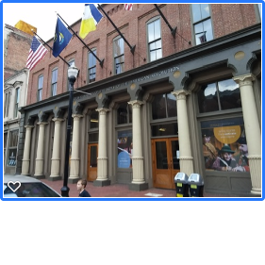The NSSAR headquarters is located at 809 W. Main Street, Louisville, KY 40202. The website address is:

[***www.sar.org***](http://www.sar.org)

The Executive Director of the National Society Headquarters and headquarters staff are paid employees. They carry out the day-to-day operation of the Society.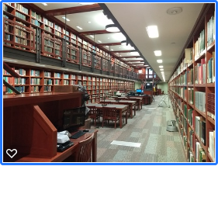 The NSSAR Library, NSSAR Compatriot Application Archives, NSSAR Merchandise Store, and NSSAR Museum are in the headquarters building. Headquarters also staffs finance, education, and genealogy activities. Meeting facilities and classrooms are also available.

Any compatriot member may visit the headquarters and use the library for research and view the museum at no charge upon presenting your national membership number.

Non-Profit: NSSAR is a tax-exempt, non-profit organization per IRS 501 (c) (3). This same status, under the umbrella of the National Society, is provided to each state society and its chapters, and each must file annual exemption notifications to the IRS.

Apolitical: NSSAR is a non-political organization. Chapters and state societies must never endorse or recommend any candidate for public office, nor can meetings include the discussion of the merits or demerits of such candidates. However, the benefit of any general question involving the social, economic, moral, or physical welfare of the people may be fairly and intelligently studied and discussed at a meeting. NSSAR may take a position on any bill or measure which may be submitted to a vote of the elected representatives of the people or a vote of the people.

Organization: Here is a very simplified organizational structure of the Society.

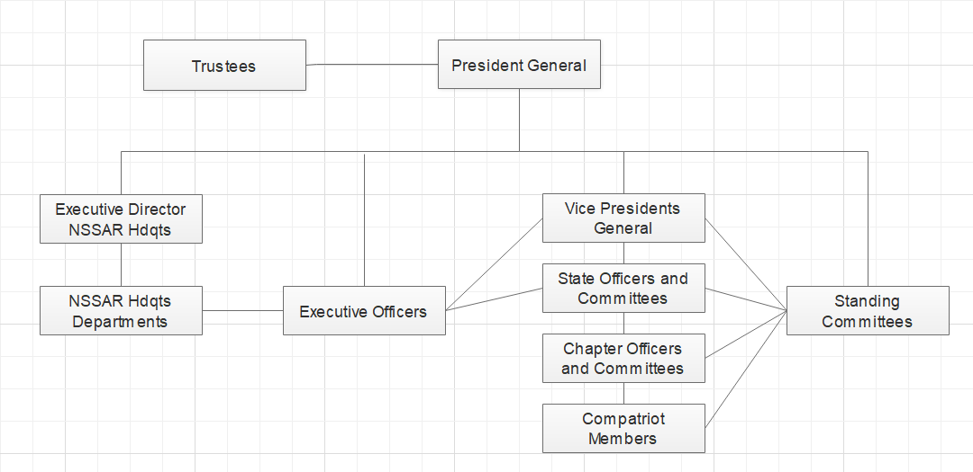

The horizontal connectors on the right side emphasize the opportunity for individual compatriots to participate and interact with other compatriots, committees, and officers at all levels of the organization. Participation occurs primarily through attendance at Leadership Meetings held in the fall and spring of the year and at the National Congress in the summer.

The President General (PG) is the official head of the organization. He, along with the Vice President Generals, and the Executive Officers: Secretary General, Treasurer General, Chancellor General, Genealogist General Registrar, General Historian General, Librarian General, Surgeon General, Chaplin General, and National Trustees, are all elected officials of the National Society. The election of the officers occurs at the National Congress held each July. All elected officers serve without compensation.

Following Congress, candidates for the following year declare their candidacy. The candidates seek endorsements from the State Societies and Districts during the year. At the Leadership Meeting in February, the Nominating Committee selects a slate of officers. Each position has one officer chosen. Nominations can also come from the floor at Congress.

The Standing Committee Chairmen, official members of the committees, and an Inspector General are all appointed by the President General. All these appointed committee members are compatriots from chapters and state societies and serve without compensation.

Appendix A, “National and State SAR Officers” lists the current National and State SAR Officers.

Societies: Societies exist in all states (North and South Dakota are combined), France, Spain, and Germany. There are 13 Districts in the U.S., one in Europe, and one that covers other International locations. A US District consists of three or four state societies. Each District is led by a Vice President General (VPG) in the National Society who reports to the President General (PG).

Seal, Insignia, & Standard: Bylaw No. 26 states that the seal of the Society shall be two and three-eighths (2-3/8) inches in diameter, charged with the figure of a Minuteman grasping a musket in his right hand, surrounded by a constellation of thirteen stars who shall be depicted in the habit of a husbandman of the period of the American Revolution, and as in the act of deserting the plough for the service of his country; the whole encircled by a band three-eighths (3/8) of an inch wide, within which shall appear the legend, “The National Society of the Sons of the American Revolution, organized April 30, 1889.”

Bylaw No. 27 states that the insignia of the Society shall comprise (1) a cross surmounted by an eagle in gold, (2) a rosette.

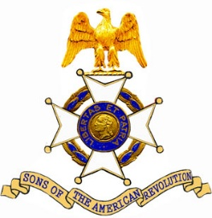Bylaw No. 27, Section 1. The cross shall be gold in color, with four arms covered with white enamel and eight gold points, the same size as a Chevalier’s Cross of the Legion of Honor of France, with a gold medallion in the center, bearing on the obverse a bust of Washington in profile, and on the reverse, the figure of a Minuteman, surrounded by a ribbon enameled in blue, with the NSSAR Motto, “Libertas et Patria,” (Liberty and Country) on the obverse, and the legend, “Sons of the American Revolution,” on the reverse, both in letters of gold. The cross shall be surmounted by an eagle in gold, and the whole decoration suspended from a ring of gold by a ribbon of a blue or deep blue, flanked by buff and white stripes, and may be worn by any member of the Society on ceremonial occasions only, and shall be carried on the left breast. Active or Past General Officers of the National Society and present or Past National Trustees (the President General shall wear the distinctive badge of his office) or by the President, active or Past, of a State Society and by the President, active or past, of a local Chapter shall be able to wear the cross on a neck ribbon.

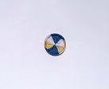Bylaw No 27, Section 2, defines the recognized emblem of the Society is a rosette, seven-sixteenths (7/16) inch in diameter, displaying the colors of the Society, blue, white, and buff. Every member of the Society is privileged to wear the rosette on all occasions when it would be in good form to do so. On a business suit, the emblem is worn on the left lapel. In those areas of the world in which suit jackets are not required for regular business or Society meetings, the emblem may be worn on the left shirt pocket or the collar. Do not wear the emblem on formal clothing.

As a member, you can wear the member rosette and the member badge (available from the NSSAR merchandise department).

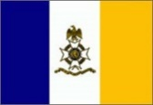

Bylaw No. 28 defines the Society Official Standard as a flag consisting of three equal vertical bars of blue, white, and buff with the blue bar at the hoist. Upon the center or white bar is the insignia of the Society and the name “The National Society of the Sons of the American Revolution.”

The NSSAR provides numerous badges and pins to be worn by members. For a complete listing of badges and pins and protocols of when and how to wear them, consult Volume IV of the NSSAR Handbook.

Medals: The NSSAR provides its members with the opportunity to receive numerous medals and certificates that can be purchased or awarded for various contributions to the NSSAR and its programs at National, State, and Chapter levels. Awards and medals are also available to members and non-members who have completed military, community, or government service outside the NSSAR.

Volume V of the Handbook provides a complete listing of medals and certificates, the requirements for acquiring or being awarded medals, pins and certificates, and protocol for wearing them.

A summary of medals and certificates that are typically earned by a new member is listed in Appendix B, “Medals and Certificates”.

Pledge: The **NSSAR Pledge** should be recited, *without modification*, as follows:

***“We descendants of the heroes of the American Revolution who, by their sacrifices, established the United States of America, reaffirm our faith in the principles of liberty and our Constitutional Republic and solemnly pledge ourselves to defend them against every foe.”***

The hands should be at the side for the NSSAR Pledge or left hand at the side and the right hand holding a written copy of the Pledge. The hand over the heart should be reserved for the United States Flag – advancing of the colors, the Pledge of Allegiance, the National Anthem, and the retiring of the colors. Many members, especially new members, read the pledge.

The **NSSAR Pledge** is not a pledge to the organization, but to liberty and our constitutional republic. Nonmembers who wish to make this pledge should be permitted and even encouraged to do so. Those who do not should stand respectfully with their hands at their sides.

The **NSSAR Mission Statement** explains in simple concise terms why our organization exists.The **Mission Statement** approved by the Executive Committee is:

***“The Sons of the American Revolution honors our Revolutionary War patriot ancestors by promoting***

***patriotism, serving our communities, and educating and inspiring future generations about the***

***founding principles of our country.”***

The **NSSAR Recessional** should be recited, without modification, as follows:

***“Until we meet again. Let us remember our obligations to our forefathers, who gave us our Constitution, the Bill of Rights, an independent Supreme Court, and a Nation of Free Men.”***

The hands should be at the side for the **NSSAR Recessional**, or left hand at the side and the right hand holding a written copy of the Recessional. Again, do not hold the right hand over the heart.

Dues: National annual dues from regular and junior members are collected by the State Treasurer during the last four months of each year. This amount includes State and Chapter dues. As of 2025, the National dues are $50 for adult members and $5 for junior members. New members whose approval date is September 1 or after, do not pay dues until the following year. A *National Life Membership* option is available, but does not cover state or chapter dues.

Fund Raising: There are several funds within NSSAR that members may contribute to that are tax-exempt. The more prominent ones are:

* **Foundation**: Created in 2000 to build the library and museum. A separate board controls this fund.
* **Center for the Advancement of American History** (CAAH): This fund helps future generations learn the blessings of being an American. It includes areas such as the Genealogical Research Library and outreach programs.
* **George Washington Endowment Fund** (GWEF): This fund uses 80% of the interest earned to support unfunded or underfunded committees and special projects of the NSSAR.
* **Other funded programs**: The Friends of the Library. The Youth Education programs. Eagle Scout Contest. Rumbaugh Oration. Knight Essay. ROTC/JROTC Essay and other educational programs.

Communication: The NSSAR will send you a quarterly copy of the NSSAR Magazine. Your annual dues cover the cost.

The National website (www.sar.org), has a link to all things NSSAR, including the Bylaws, the NSSAR Handbook, and merchandise.

# THE CENTRAL DISTRICT

The National Society is divided into Districts. Each district is headed by a Vice President General (VPG). Each VPG has three or four state societies in his District, and works directly with the various State Presidents in promoting the President General’s programs.

The Kentucky Society along with the West Virginia, Indiana, and Ohio Societies make up the Central District.

Meetings & Events: The Central District holds a minimum of one meeting for its member states in annually.

Within each of the states of the Central District, there are NSSAR memorial events held annually.

**Indiana - George Rogers Clark Memorial Service held in Vincennes, Indiana**. This memorial event is held on the Saturday of Memorial Day weekend in remembrance of those who died in the battle for Fort Sackville. On February 25, 1779, Lt. Colonel George Rogers Clark led American forces against the British at the Wabash River, capturing the fort near what is now Vincennes, Indiana.

**Ohio - Fort Laurens Memorial Service held in Bolivar, Ohio**. This memorial event, held in early or late July, is in remembrance of those who died at Fort Laurens in 1778-1779. Fort Laurens was the only Revolutionary War fort in Ohio and was completed by then Gen. Lachlan McIntosh leading Virginia and Pennsylvania troops in December 1778. It was intended that the fort be built to launch an offensive against British held Fort Detroit. Besieged by British and Indian forces, the fort was abandoned in August of 1779.

**Kentucky - Battle of Blue Licks Memorial Service held at Blue Licks Battlefield State Park, Carlisle, Kentucky**. This memorial event is held in remembrance of the militia who died at the Battle of Blue Licks on August 19, 1782. Although the British had surrendered at York Town on October 19, 1781, isolated conflicts continued between British and Indian forces against American settlers in Kentucky, Western Pennsylvania, and Ohio continued. The NSSAR and DAR recognize this battle as the final battle of the Revolutionary War.

**West Virginia-Battle of Point Pleasant Memorial held in Point Pleasant, West Virginia**. This memorial is held in early October in remembrance of the Virginia Militia, who lost their lives in the Battle of Kanawha on October 10, 1774. The militia, under the command of Col. Andrew Lewis, was dispatched by Royal Governor Lord Dunmore, and fought Shawnee and Mingo warriors lead by Shawnee Chief Cornstalk, who was encouraged by the British at Fort Detroit to engage the militia. The NSSAR and DAR recognize this battle as the first battle between colonial troops and Great Britain.

*The Battle of Blue Licks Memorial Monument, Blue Licks Battlefield State Park, Kentucky*

# THE KENTUCKY STATE SOCIETY

History: With the approach of the Centennial (in 1890) of the inauguration of Washington as the first President of the United States, there was aroused a general and widespread interest in the early history of this nation and in its struggle for liberty.

The men whose forefathers took part in the establishment of the nation were naturally drawn together, and in some of the older States formed themselves into societies to gather scattered bits of history and save them for coming generations; to preserve alive a memory of the men who gave so much for country and paid so dear a price for liberty; to inculcate in the minds of the rising generations a knowledge of what they fought for, and a love of the principles they held so dear.

To better carry out these noble purposes the New Jersey Society issued the following circular through the press, and personally to many a gentlemen who might be interested in such a movement:

CALL FOR A CONVENTION TO ORGANIZE A NATIONAL SOCIETY OF THE SONS OF THE REVOLUTION.

NEWARK, NEW JERSEY, APRIL 10, 1889.

The special committee of the “SOCIETY OF THE SONS OF THE REVOLUTION of New Jersey,” to whom was referred the duty of inviting the organizing of a co-equal sister Society in every State and Territory in the Union and in France, each Society electing delegates to organize a National Society, made up of the president, one delegate-at-large, and one delegate for each one hundred or fraction of one hundred, exceeding fifty, members; every Society to be entitled to at least three representatives, hereby calls a meeting of such delegates to the National Society, elected or to be elected, to take place at 9:00 AM, April 30, 1889, the one hundredth anniversary of the inauguration of George Washington as first President of the United States, in Fraunces’s Tavern, New York, corner of Pearl and Broad streets, in the room where General Washington made his farewell address to the officers of the Revolutionary Army (which has kindly been placed at our disposal by the proprietor for that purpose). It is hoped that every Society will be fully represented.

Wm. O. McCowell,

Chairman.

Wm. S. Stryker,

W. C. Pumpelly,

Special Committee.

A copy of this circular was sent to the Governor of Kentucky, General S. B. Buckner, who called on such persons as might be eligible to meet in the Senate Chamber in Frankfort, on April 8th. To this invitation some thirty-one persons responded, among them Dr. A. J. Gano, of Scott County, and Ben. C. Allin, of Mercer County, both of whom were sons of officers of the Continental Army. This meeting resolved to form a Kentucky Society of Sons of the Revolution, and appointed a committee on organization consisting of Gov. S. B. Buckner, chairman; Dr. A. J. Gano, Thos. M. Green, Lewis E. Harvie, Sam. E. Hill, E. Polk Johnson, Ira Julian, Wm. Lindsay and Ed. Porter Thompson, and adjourned to meet again on 23rd inst. At this meeting thirty-eight persons were enrolled as members.

On the 23rd inst. the Society met in the Senate Chamber, as agreed, and heard the report of the committee on Organization, who reported a constitution modeled after that of the New Jersey Society.

Ladies were exempted from the payment of initiation fees and annual dues, which were placed at: Initiation Fee, $1; Annual Dues, $2; Life Membership, $50.

Non-Profit/Charitable: The Kentucky Society is an IRS 501 (c) (3) organization under the umbrella of the National Society. It is registered in the state of Kentucky with the Secretary of State as a non-profit Kentucky business, and it is registered with the Kentucky Attorney General’s office as a Charitable Organization. It operates under its own Constitution and Bylaws which can be found on the KYSSAR website.

Officers: The KYSSAR Officers are elected by members attending the Fall KYSSAR Meeting in November with Officers Insulation at the Spring Annual Meeting held each March. The nominating committee presents a list of officers however nominations from the floor may be made. Any Kentucky Society member in good standing may attend and vote. Elected officers are: President, President-Elect, Vice President, Secretary, Recording Secretary, Treasurer, Assistant Treasurer, Chancellor, Genealogist, Registrar, Surgeon, Historian, Chaplain, Assistant Registrar #1, #2, #3 and #4. The President chooses all other officers and chairmen of standing committees, which are approved by the BOG. All elected and appointed officers serve without compensation.

Appendix A, “National and State SAR Officers” provides a list of current National and State SAR Officers.

To review the offices and associated responsibilities, see the Kentucky Bylaws on the KYSSAR website. To review the names and addresses of current officers, go to the “About Us” tab of the Kentucky website and click on “Officers”.

Board of Governors: The affairs of the Society are vested in the Board of Governors (BOG), which is deemed for all purposes to constitute the Board of Directors within the meaning of the Kentucky Non-profit Corporation Law.

The BOG consists of the following persons, occupying certain positions within and without the KYSSAR as ex-officio, who constitute the entire membership of the Board of Governors:

* The elected KYSSAR Officers (President, President-Elect, Vice President, Secretary, Recording Secretary, Treasurer, Assistant Treasurer, Chancellor, Genealogist, Registrar, Surgeon, Historian, Chaplain, Assistant Registrar #1, #2, #3 and #4)
* The Kentucky National Trustee and Alternate Trustee,
* Chapter Presidents
* General Officers of the National Society who are members of the Kentucky Society,
* One delegate from each chapter, and
* Immediate past KYSSAR President.

The BOG acts on behalf of the State Society’s membership. The KYSSAR holds a minimum of three BOG meetings per year.

Executive Committee: The Executive Committee consists of the President, President-Elect, Vice President, Secretary, and Treasurer. The Executive Committee has the authority to carry out the policies of the Board of Governors, and to act on the State Society’s behalf between meeting of the Board of Governors.

Standing Committees: There are several standing committees established to assist in the administration of the KYSSAR; or exist to support national and state programs. A complete list of these committees and their chairmen is provided in the Bylaws, which can be found on the KYSSAR website.

Meetings: The KYSSAR holds three meetings each year:

* **Spring Annual State Meeting** is typically held in March at a location determined by the incoming KYSSAR President. All members of the Kentucky Society in good standing may attend, and vote on any resolutions coming before the membership and election of officers.
* **Summer State Meeting** is held in mid-August in conjunction with the Battle of Blue Licks Memorial Ceremony, which is a National Society event.
* **Fall State Meeting** isheld in November at a location determined by the KYSSAR President.

All members and their spouses are encouraged to attend all the KYSSAR meetings.

Dues: The current annual State dues of the KYSSAR are $18.00 for regular members. Junior members do not pay dues. Dues are collected beginning in September for the following calendar year by the State Treasurer.

Programs: The KYSSAR, with the help of its chapters, supports the National Society Programs. Details of these programs can be found on the National website, and in the KYSSAR Handbook found on the KYSSAR website. Chapters support many of these programs. See the Participation section in the [Insert Chapter Name] part of this Workbook following, where several of these programs are presented.

Color Guard: The KYSSAR has a very active state color guard divided into the Northern, Central, and Western Brigades. The State Society and Chapter Color Guards are part of the National Color Guard. Any compatriot that has a militia or continental uniform is eligible to be a member of the color guard. The Color Guard is one of the ways the National and State Societies become visible to the public and acts as ambassadors for the Kentucky Society. The color guard also helps to support community programs by participating in parades, flag postings, school programs, and other events.

DAR: The KYSSAR partners with the Daughters of the American Revolution (DAR), by reciprocal attendance at annual state meetings, posting flags, exchanging speakers, and supporting membership recruitment.

Ladies Auxiliary: The KYSSAR Ladies Auxiliary is organized so that a spouse, daughter, or female bloodline relative can be involved in Society activities. They are always welcome at meetings, and it is a time that they can meet and work on worthwhile projects supporting their programs or Society programs. Medals and certificates are also available for ladies who participate.

C.A.R.: The State Society supports the Children of the American Revolution (C.A.R.) Society. We encourage members to work with this organization. Junior NSSAR members are encouraged to join the C.A.R.

Endowment: The KYSSAR Endowment Fund is composed of gifts and bequests made to the Society. The endowment is retained in a separate institution from the current (checking) account and is managed by the Executive Committee.

**Fundraising:** Fundraising programs are held for special needs of the Society as required. The Society does not conduct annual or regular fundraising events.

Publications: The KYSSAR publishes the Kentucky Pioneer newsletter. It is emailed to all Kentucky members who previously provided an email address, and is also available on the KYSSAR website. There is no charge for this publication.

# [Insert Chapter Name]

As the [Insert Chapter Name] President, I want to personally welcome you to our Chapter. I hope that you will be an active participant in the many programs that the chapter offers. Don’t be shy – Volunteer.

[Insert President’s Name]

History: [Insert as much of the chapter’s history as is appropriate. The text will adjust as needed.]

Constitution & Bylaws: The [Insert Chapter Name], is organized under a Constitution and set of Bylaws. A copy can be provided upon request to the chapter Secretary.

Not for Profit Organization and Charitable Organization: Under the umbrella of the National Society, the [Insert Chapter Name] SAR is an IRS 501 (c) (3) chartered organization. It is registered with the Kentucky Attorney General’s office as a charitable organization. It operates under its own Constitution and Bylaws.

Officers: The Bylaws establish chapter officers. A nominating committee annually presents a slate of officers at the designated chapter business meeting. Nominations may also be made from the floor, and members vote to elect the officers. Detail responsibilities of officers can be found in the Chapter Bylaws. A brief description is as follows:

**President** - Responsible for overall chapter programs and meetings.

**Vice President** - Acts for the President in his absence and supports the President’s agenda.

**Secretary** - Records meeting minutes and records of participation.

**Treasurer** - Maintains the chapter financial records.

**Chaplain** - Provides spiritual support for the chapter.

**Historian** - Maintains a historical file on all chapter activities and publicity.

**Registrar** - Processes membership applications and reinstatements.

**Color Guard Commander** - Plans and organizes color guard events.

See Appendix C, “[Insert Chapter Name] Officers” for a list of current officers.

Meetings: Chapter meetings and events are scheduled at the beginning of the year. See Appendix D, “Chapter Meetings and Events” for this year’s schedule of events.

Dues and Donations: Dues notifications are sent out beginning in September of each year. They are payable to the Kentucky Society, and sent to the Kentucky Society Treasurer.

Currently, chapter dues are [Insert Amount] for Regular and Life members. Juniors pay no Chapter dues. Memorial members (Regular and Junior) pay chapter dues upon application and none after that.

Donations may be made directly to the chapter to support the costs of any of its programs. The chapter has no endowment funds.

Chapter Committees: Chapter committee chairmen are appointed by the President to support national, state, and chapter programs. See the programs presented below to see how you can help with chapter programs.

Opportunities to Participate in the Chapter:The [Insert Chapter Name] participates in many of the National Society programs. The programs are in support of the National patriotic, historical, and educational objectives. The listing below will acquaint you with many of the programs that contribute to the chapter earning points towards national recognition and awards.

As you read through these programs, decide which of them you might be interested in supporting. The questions after each program description will help you decide which programs may be of interest to you. Your answers to these questions will help you complete the summary sheet found on the last page of this workbook. Providing this summary page to your mentor will help the chapter officers get you involved.

### Americanism Award

Each year the [Insert Chapter Name] participates in the National Americanism Award. The award is based on chapter participation in events and programs established by the National Society to promote the principles of freedom and liberty for all Americans. Members report their involvement in these events or programs to the chapter officer or member responsible for maintaining the score sheet and recording the participation in one of several categories. Awards are presented to chapters at the National Congress each July for the previous calendar year. Each chapter can compare its results against other chapters or their previous scores to determine how they are performing in meeting the Society objectives.

* Do you have computer spreadsheet skills? Yes No
* Are you interested in helping the chapter by maintaining a spreadsheet or other administrative work? Yes No

*Please record the answers on the summary sheet at the end of the Workbook.*

### ***Youth Awards***

The [Insert Chapter Name] supports the Youth Awards Program. This program encourages children in elementary, middle, or high schools (as well as various youth groups such as Scouting America, Trail Life USA, American Heritage Girls, Girl Scouts, and JROTC, etc.), to participate in various patriotic, educational, and historical contests. Cash awards and certificates are available at the chapter, state, and national levels.

Contests are as follows:

* + Grades 3-5 Poster contest
  + Grades 6-8 Brochure contest
  + Grades 6-12 ……………………………… Youth Video Contest – Individual or Group Projects Accepted
  + Grades 9-12 Rumbaugh Oration contest
  + Grades 9-12 Knight Essay contest
  + C.A.R. Award Outstanding support of C.A.R. goals
  + Eagle Scout Contest………………………. Open to Eagle Scouts who have not yet reached their 19th birthday during the year of application, and who complete an application, a four-generation ancestor chart, and a less than 500-word patriotic-themed essay.
  + American History Teacher Award………. Exceptional teaching on Revolutionary War period subjects
* Do you have school-age children, grandchildren, nieces, or nephews? Yes No
* Were you a teacher, or do you know a secondary education teacher? Yes No
* Were you a Boy Scout, or are you interested in the scouting program? Yes No
* Are you willing to help with recruiting entrants for a youth contest? Yes No

*Please record the answers on the summary sheet at the end of the Workbook.*

### 

### **Flag Award**

The [Insert Chapter Name] supports the National Society's annual program to honor individuals and local companies/organizations that fly our country's flag for patriotic purposes, not for commercial purposes and advertising or if required by law. Participation involves identifying candidates, documenting the proper display of the flag, printing a certificate, and presenting the certificate in a brief ceremony.

* Are you willing to attend the recognition ceremony at the recipient’s location? Yes No
* Are you willing to help by participating in the Flag Program? Yes No

*Please record the answers on the summary sheet at the end of the Workbook.*

### **Color Guard**

The [Insert Chapter Name] has a color guard whose members wear uniforms or clothing representative of the Revolutionary War period. A simple period correct uniform can be inexpensively assembled with a militia frock and tricorn hat. Other hats and homemade frocks may be appropriate, as long as they are period correct.

The color guard members are the most public representatives of the SAR and are a highly visible means to express Patriotism and draw attention to the period of the American Revolution. The color guard also participates in grave marking ceremonies; presents and retires the flags at community, historical or DAR events; participates in memorial services; or stands guard during a viewing of a deceased member or at a national historic site. Color guard duties can be at the chapter, state, or national level. Participants can earn medals to acknowledge support of the events.

* Are you interested in wearing a period uniform or militia clothing? Yes No
* Would you like to become a member of your chapter color guard? Yes No

### **Grave Markings**

The [Insert Chapter Name] supports the National Society’s Patriot Grave Marking program. The chapter seeks out gravesites of Patriots, restoring or replacing their stones and marking the gravesites with SAR grave markers. The marking process concludes with a ceremony recognizing the patriot and his descendants, if present. Chapter members may receive the National Grave Marking medal after having performed a key role in 15 patriot grave markings.

* Would you be interested in conducting field work to locate Patriot graves? Yes No
* Do you enjoy researching biographical information? Yes No
* Do you enjoy writing stories and biographies? Yes No
* Would you like to support the chapter’s grave marking program? Yes No

### **Veteran Service and Support**

The [Insert Chapter Name] supports the National Society’s Veteran Service Awards program. This program provides certificates and medals to members who served in our nation’s military. There is a Veteran War Service award for those who were in a war zone and Veteran Service Award for those who have served but were not in a war zone.

* Are you a veteran in the United States Military? Yes No

The [Insert Chapter Name] supports the National Society’s Veteran Support Awards program. This program recognizes members who have given of their time to support veterans or veteran’s programs. The chapter collects various donation items for VA hospitals and other veteran support organizations.

* Have you been involved in veteran’s organizations and events? Yes No
* Would you like to support the chapter’s Veterans Program? Yes No

### **Speaker Bureau**

The [Insert Chapter Name] supports the National Society’s patriotic, historical, and educational objectives by offering a speaker’s bureau to local organizations and schools. Participants provide presentations on a variety of topics covering colonial America, the American Revolution, our founding documents and principles, and other Patriotic subjects.

* Do you enjoy researching and putting together presentations? Yes No
* Do you enjoy presenting but not preparing speeches? Yes No
* Would you like to develop and/or present revolutionary period presentations? Yes No

### Patriot Research System Support

The National Society has undertaken a major project to combine three old databases into one database called the Patriot Research System (PRS). The database also includes patriot biographies written by SAR members. Databases available on other websites like the DAR website and the Find-a-Grave website are also linked to the PRS, providing the ability to research revolutionary war patriots easily.

* Do you like using computer skills and enjoy navigating websites? Yes No
* Are you interested in entering data on Patriots into a database? Yes No
* Are you interested in researching biographical information on Patriots? Yes No
* Would you be willing to help build the Patriot Research System? Yes No

### 250th Anniversary of the American Revolution

The [Insert Chapter Name] is supporting the National Society in its recognition of the 250th Anniversary of the American Revolution. This program promotes public attention to the various events celebrating our nation’s milestone anniversary. This program includes partnering with local and state organizations in their commemoration of the anniversary.

* Are you a member of other organizations that are planning events? Yes No
* Would you be willing to help the chapter organize and hold events to commemorate the 250th Anniversary of the American Revolution? Yes No

### Wreaths Across America

Wreaths Across America is a national veteran’s remembrance event held on the second or third Saturday in December. The event is led by local community organizations and held at a local cemetery. This program is an outgrowth of the wreath laying ceremony begun at Arlington National Cemetery in 1992. The organizers solicit sponsorship of wreaths from the public and businesses. Volunteers gather on the appointed Saturday and place wreaths on the graves of the veterans. Prior to laying the wreaths, each Wreaths Across America location across the nation conducts a brief ceremony at noon EST. Both SAR and DAR organizations support this veteran recognition effort.

* Do you have an interest in honoring our nation’s veterans? Yes No
* Are you willing to contact people or businesses for wreaths sponsorships? Yes No
* Would you be willing to help the chapter organize and hold this event? Yes No

### Attendance at State and National Meetings

Being a part of the State and National Societies provides the opportunity to see how the organization operates and to participate in various committees of the SAR.

There are two National Leadership meetings held each year; one in September and one in February. All the national committees meet at these times to discuss, plan, and promote their various programs. There is also a National Trustees meeting where society business is conducted. The Leadership Meetings also include a casual supper on Friday and a formal supper on Saturday. Included in the program are events for the Ladies Auxiliary. All compatriots and family members are welcome to attend the activities at the Leadership Meetings.

There are three State Society meetings held each year. Any compatriot may attend the meetings and participate in the discussions.

* Are you interested in defining or coordinating programs? Yes No
* Would you like to attend a Leadership Conference? Yes No

***CONGRATULATIONS [INSERT NEW MEMBER NAME]***

***YOU ARE ON YOUR WAY!***

Now find others who may want to join. The Kentucky Society needs your active participation to honor our Patriots, remember our veterans, and educate our youth. Talk to your chapter president about opportunities for you to get involved.

Welcome to the SAR and to the [Insert Chapter Name]!

# Appendix A - National Officers & Offices, July 2024 - 2025

## National Society - General Officers

**President General**

Darryl Addington, M.D., North Carolina SAR

**Secretary General**

Michael J Elston, Esq., Virginia SAR

**Treasurer General**

William A. Greenly, Georgia SAR

**Chancellor General**

Edmon H. McKinley, Esq., Alabama SAR

**Genealogist General**

Gary O. Green, North Carolina SAR

**Registrar General**

T. Brooks Lyles, North Carolina SAR

**Historian General**

Jeffery D. Thomas, Virginia SAR

**Librarian General**

Keith A. Weissinger, M.D., Washington SAR

**Surgeon General**

John A. Turley, M.D., West Virginia SAR

**Chaplain General**

Rev. Dr. J. Vernon Welkner III, Kansas SAR

**Vice President General-Central District**

Wayne Eells, Indiana SAR

## Trustee

**National Trustee**

Timothy C. Brown, Nicholasville, KY

**Alternate National Trustee**

Scott Giltner, Louisville, KY

# Appendix B - Kentucky SAR Officers, March 2025 - 2026

**President**

Patrick Wesolosky, Lexington, KY

**President-Elect**

Richard Quire, Lawrenceburg, KY

**Vice President**

Patrick McMurchie, LaGrange, KY

**Secretary**

James Stinnett, Salvisa, KY

**Recording Secretary**

Donald Swearingen, Paducah, KY

**Treasurer**

Douglas Collins, Louisville, KY

**Assistant Treasurer**

Steve Vest, Frankfort, KY

**Chancellor**

Hon. Joe Hendricks, Jr., Russellville, KY

**Genealogist**

Christopher Canine, Goshen, KY

**Registrar**

Steve Gahafer, Lexington, KY

**Surgeon**

Michael Davis Rankin, M.D., Harrodsburg, KY

**Historian**

Delbert White, Harrodsburg, KY

**Chaplin**

James Gearhart, Paducah, KY

**Assistant Registrar – Louisville Metro Region**

Christopher Canine, Louisville, KY

**Assistant Registrar – Eastern Region**

Jackie Miller, Cynthiana, KY

**Assistant Registrar – Western Region**

Joe Clancy, Lexington, KY

**Assistant Registrar – Central Region**

Vacant

# Appendix C – Medals and Certificates

The following medals and certificates are those most frequently received by Kentucky Society members. Once the requirements of the medal are approved the National Society, State Society or Chapter purchases the medals. Details for each medal are provided in the National Society Official Handbook Volume V, Precedence Section. The compatriot may also work toward other medals or certificates. For the complete list of medals, certificates, and their requirements, see Volume V of the NSSAR Handbook.

Medals awarded by the *National Society* for service to the NSSAR.

* Lafayette Volunteer Service Medal. Awarded for performing 40 hours of volunteer service on assigned NSSAR programs.
* Patriot Grave Marking Medal. For planning or participation in key roles for the marking of 15 Patriot graves.

Medals awarded by a *State Society* to compatriots for service to the SAR.

* Bronze Color Guard Medal. For participation in chapter and state color guard events.

Medals awarded by the National Society, State Society, or Chapter for military service and service to veterans

* War Service Medal. For compatriots who complete an application and provide documentation (DD214) verifying military service in a branch of the US Military in a hazardous or war zone.
* Military Service Medal. For compatriots who complete an application and provide documentation (DD214) of active duty service in a branch of the US Military.
* Service to Veterans Medal. For completion of the application on providing various types of service to veterans or veterans organizations.

250th Anniversary of the American Revolution Recognition Program – The recognition program is designed to encourage and recognize those compatriots, chapters and societies that participate in local, state, national and international events which publicly educate, and recognize, honor, and celebrate the events and heroes of the period surrounding the American Revolution. Participation involves the planning and execution of these events, as well as attendance. The medal covers any event celebrating and promoting the 250th Anniversary. Scorekeeping is the responsibility of each compatriot and awarding authority. The awarding authority for each medal is as follows. The Bronze Medal is authorized and recorded by the local chapter. The Silver Medal is Authorized and recorded by the state society. The Gold Medal only is authorized and recorded by the NSSAR 250th Anniversary Committee. Information on the Medals can be found under the NSSAR Website tab America 250 in the middle of the page is a link to 250th Anniversary Gold Medal Application Form Download this will provide information for all 250 Medals.

Certificate awards presented for service to the SAR.

* Certificate of Appreciation. To acknowledge outstanding support given to the Sons of the American Revolution.
* U.S. Flag Retirement Certificate. Presented for participation in the collection and destruction of worn, soiled, or otherwise unserviceable United States flags.

Pins awarded for donations to national programs.

* Friends of the Library membership lapel pin can be awarded for a nominal $25 gift to the Friends of the Library. Annual renewal of membership is appreciated. Four additional levels of contributions are available.
* George Washington Endowment Fund Fellow lapel pin can be obtained for a gift of $1000 to the George Washington Endowment Fund.

# Appendix D – [Insert Chapter Name] Officers

President (Name):

Phone: Email:

1st Vice President (Name):

Phone: Email:

2nd Vice President (Name):

Phone: Email:

Secretary (Name):

Phone: Email:

Treasurer (Name):

Phone: Email:

Registrar (Name):

Phone: Email:

Genealogist (Name):

Phone: Email:

Historian (Name):

Phone: Email:

Chaplin (Name):

Phone: Email:

Color Guard Commander (Name):

Phone: Email:

# Appendix E - [Insert Chapter Name] Meetings and Events

|  |  |  |  |
| --- | --- | --- | --- |
| Date | Time | Event | Location |
| Dec 29, 2021 | 11:00 AM | Wreaths Across America | Washington D.C. |
|  |  |  |  |
|  |  |  |  |
|  |  |  |  |
|  |  |  |  |
|  |  |  |  |
|  |  |  |  |
|  |  |  |  |
|  |  |  |  |

# My Part Participation - Summary Sheet

Name _____________________________________________

We ask that you complete this summary sheet and turn it in at the end of the workbook presentation. It will help us involve you in our programs where you have the experience, skills, or interest. If you are not ready to help at this time, *that is okay*. You may want to take some time to get to know the chapter better. The summary sheet also allows the chapter to have a record of your interests so opportunities in which you might be interested can be shared with you as they become available.

Based on the answers entered in the Orientation Workbook, please indicate your willingness to help by checking each area of interest:

* Helping with chapter administrative tasks and programs? (i.e., Americanism Award, newsletter, data entry, leadership, meeting preparation) Yes Not now
* Working with one or more youth programs Yes Not now
  + Which one/ones?
* Participating in the chapter flag program? Yes Not now
* Participating in the chapter color guard? Yes Not now
* Participating in the chapter grave marking program? Yes Not now
* Participating in the chapter veterans programs? Yes Not now
  + Are you a veteran of the United State Military? Yes No
* Preparing and/or presenting revolutionary period talks? Yes Not now
* Participating in the National Society’s Patriot Research System? Yes Not now
* Participating in the 250th Anniversary programs? Yes Not now
* Participating in Wreaths Across America? Yes Not now
* Helping organize and hold chapter events? Yes Not now

THANK YOU FOR HELPING US GET YOU STARTED IN BEING AN ACTIVE INVOLVED COMPATRIOT.

*(Continued on reverse)*

# Where I am Willing to Help - Summary Sheet

What special interests, skills, experience, or hobbies do you have that might add to the chapter’s Patriotic, Historical, and Educational activities?